# Uniform Distribution:

Parameters:

* Range: 0 to 1
* Population size (N): 1000
* Sample size (n): 31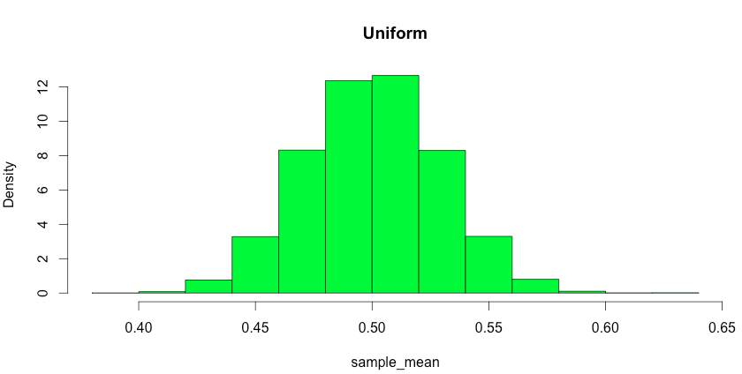

# Normal Distribution:

Parameters:

* mean: 0, variance = 1
* Population size (N): 1000
* Sample size (n): 31

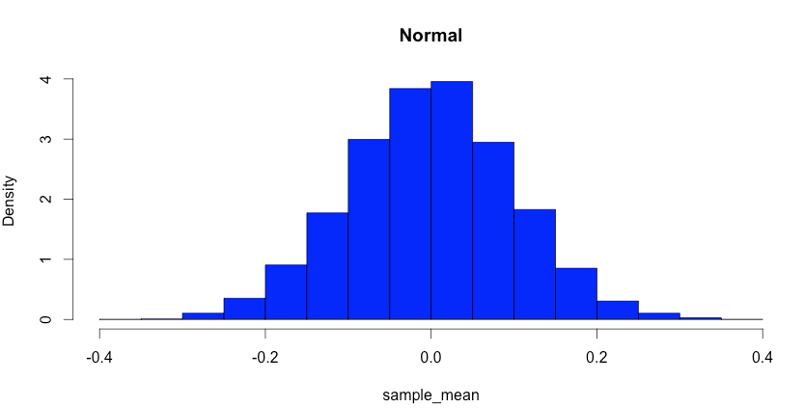

# Poisson Distribution:

Parameters:

* 
* Population size (N): 10000
* Sample size (n): 101

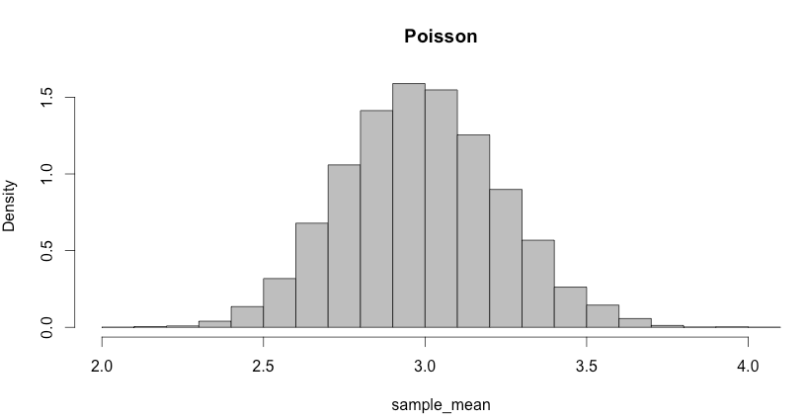

# Binomial Distribution:

Parameters:

* 
* Population size (N): 10000
* Sample size (n): 101

